**LAB # 05**

**SUPERVISED LEARNING (DECISION TREE)**

**OBJECTIVE**

Implementing supervised learning, DTS algorithm for training, testing and classification.

**Lab Tasks**

1. Implement the Decision tree algorithm on the data given in the table. 1 and predict the new entry entered by the user.

Table. 1

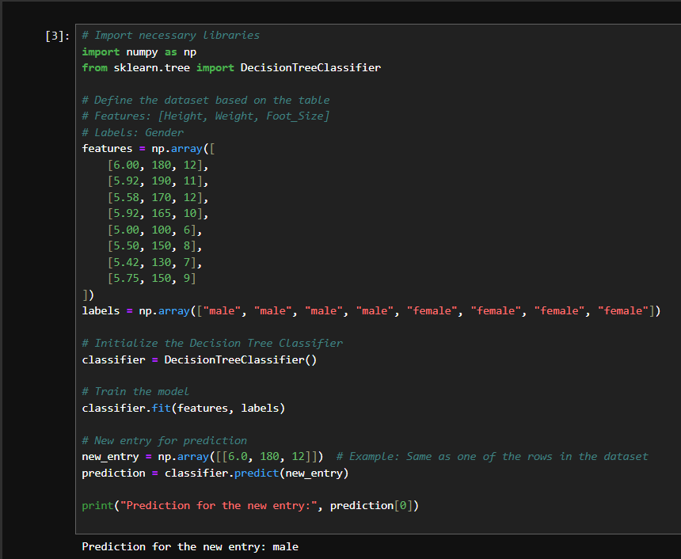

**Output:**



1. Implement Decision Tree using table. 1 in such a way that the new entry becomes the part of the given dataset.

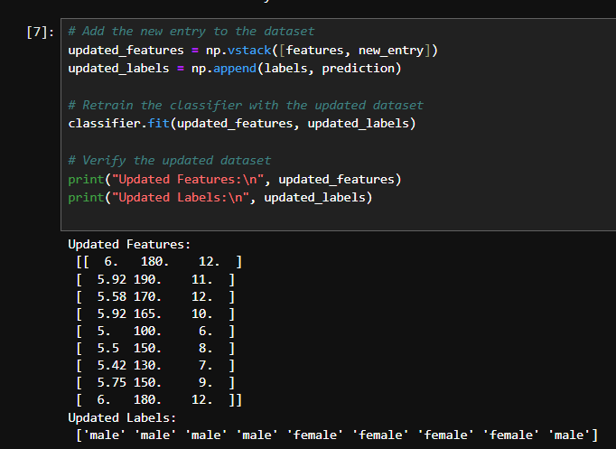

**Output:**



1. Implement Decision Tree using table. 1 without the use of Pandas library. You can use numpy.

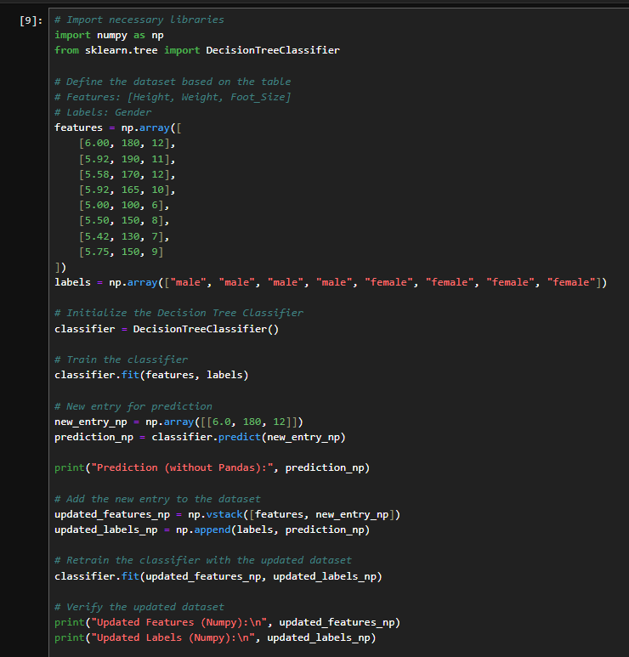

**Output:**

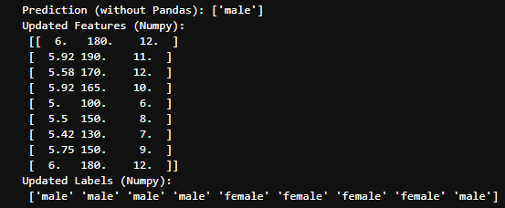

Home task

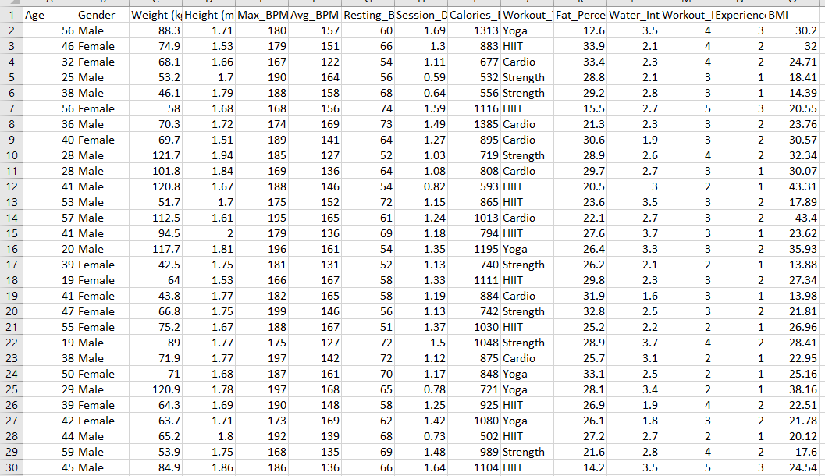

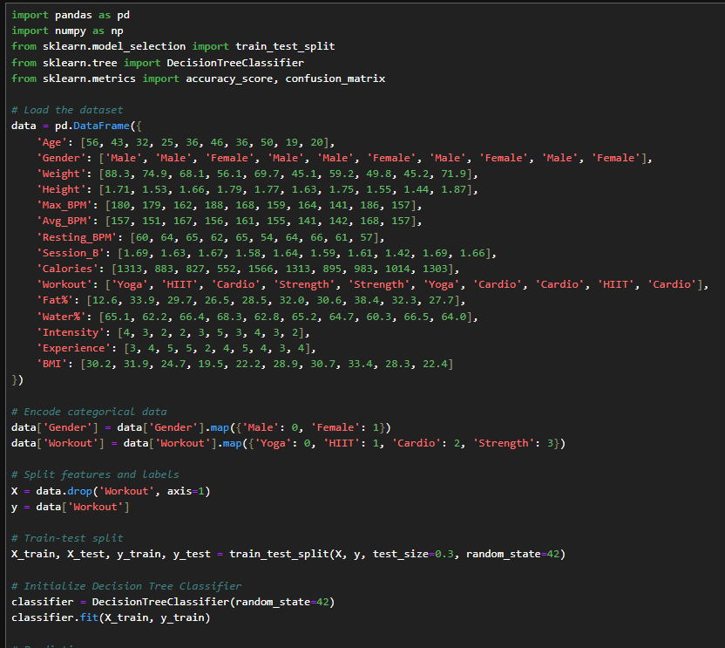

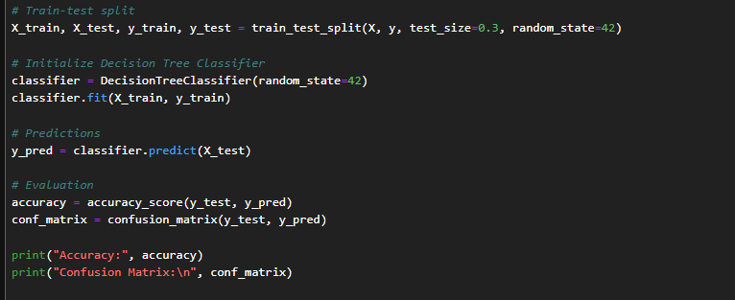

**Output:**

